Assignment 5
Algorithm for Study Planner with Task Reminder
1. Start
- Initialize the system.
- Load user data (tasks, schedule, reminder settings).
2. Input Section
2.1 Get User Details
- Ask user for:
- List of subjects
- Available study hours per day
- Preferred study time ranges
2.2 Get Task Details
For each task:
- Task Name
- Subject
- Deadline (date/time)
- Estimated Time Needed
- Priority Level (High/Medium/Low)
- Reminder Preference
3. Task Processing
3.1 Sort Tasks
Sort tasks based on:
- Deadline (earlier first)
- Priority
- Estimated time
3.2 Break Tasks into Study Sessions
- Split long tasks into manageable study sessions.
4. Build Study Timetable
4.1 For Each Day
- Detect available time slots.
4.2 Assign Tasks
- Insert sessions into earliest possible slots.
4.3 Handle Conflicts
- Resolve overlapping sessions.
- Notify user if schedule overload occurs.
5. Reminder System
5.1 Reminder Scheduling
- Calculate reminder time based on user settings.
5.2 Notification Logic
- Trigger reminders if tasks not completed.
5.3 Snooze Feature
- Delay reminders when snoozed.
6. Task Completion Updates
- Mark sessions or tasks as completed.
- Recompute remaining workload.
7. Daily Review
- Display completed, pending, overdue tasks.
- Carry forward unfinished tasks.
8. End

Flowchart

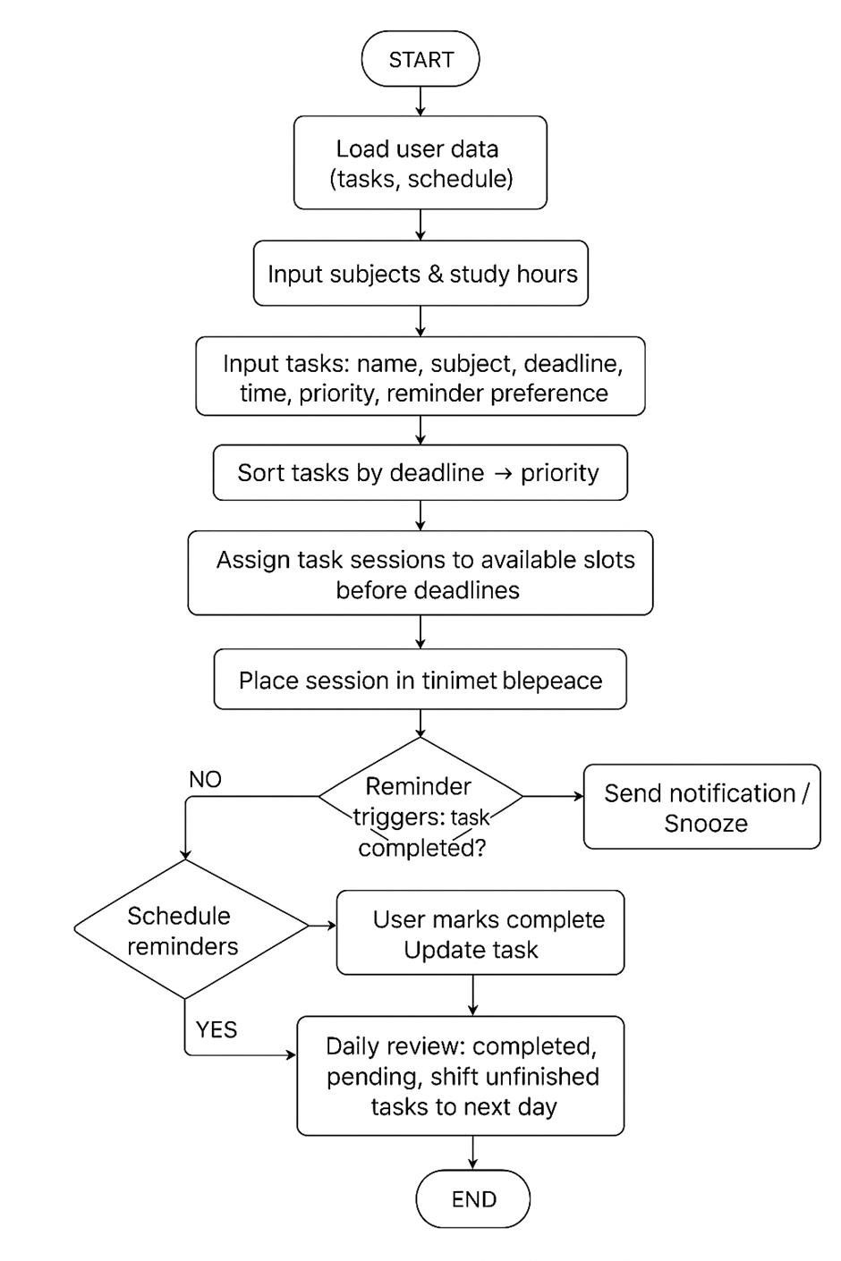Infographic
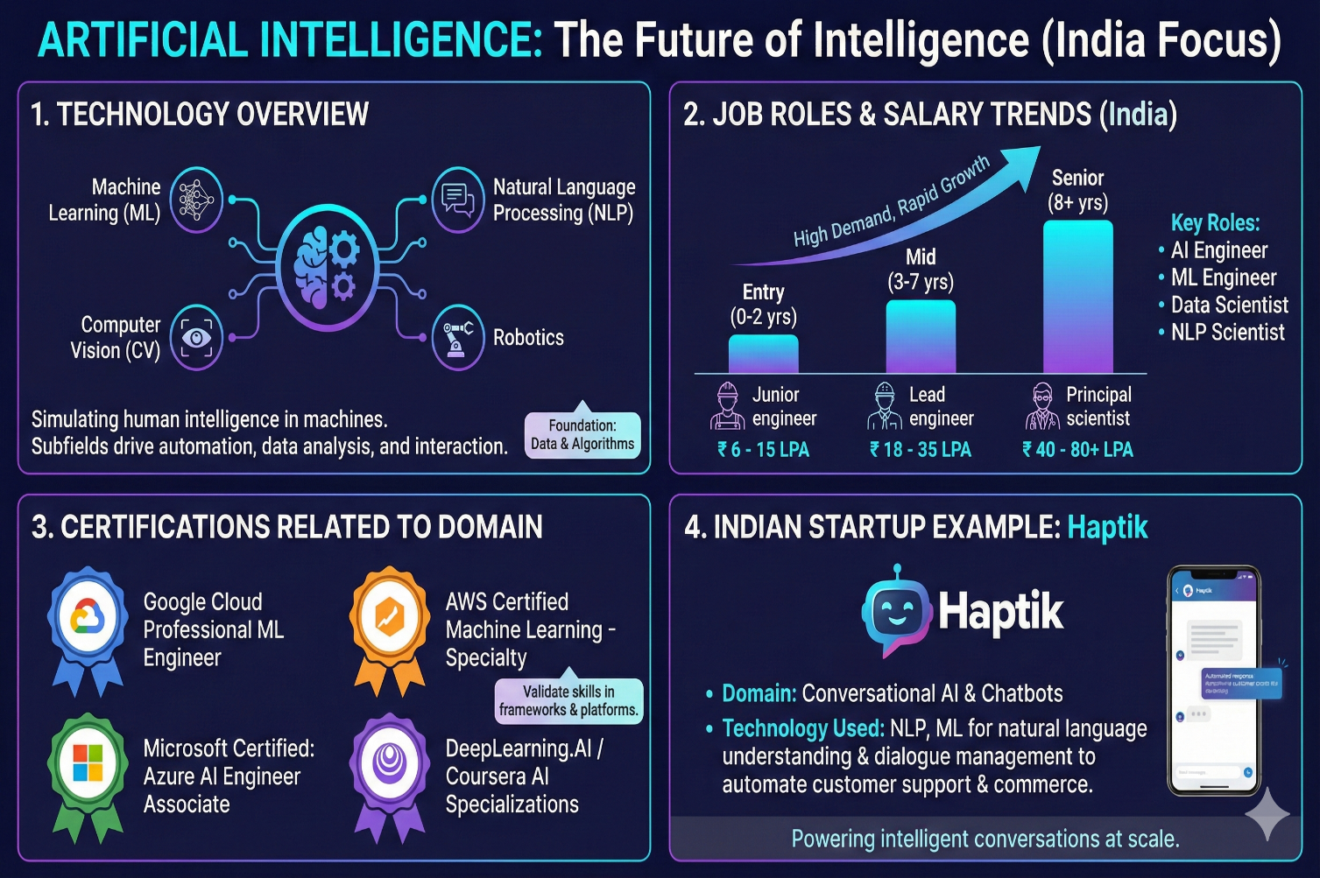
Linux Commands
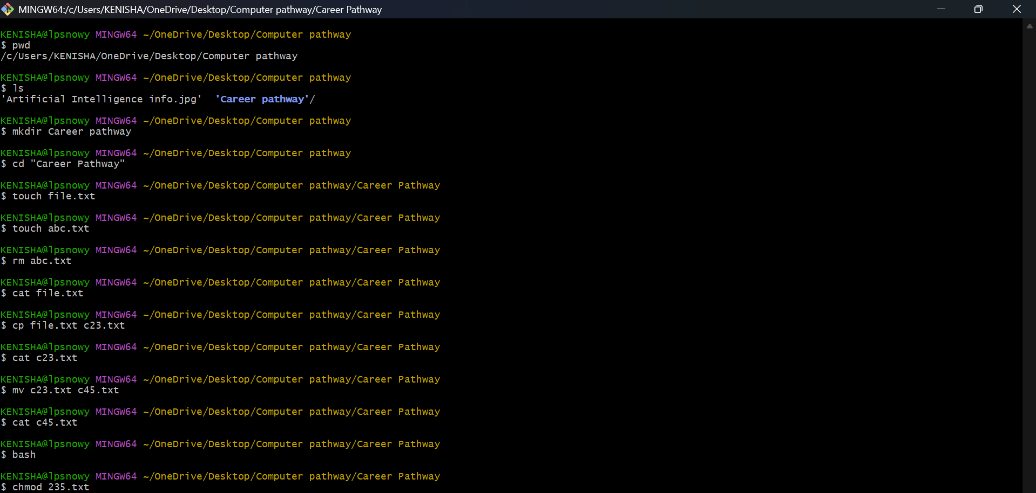

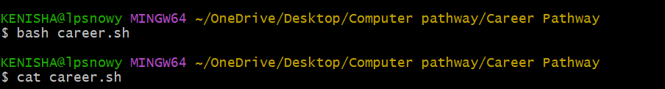

Career Planning and Professional Readiness
1.SMART GOALS
- Academic
Securing a CGPA of 8.5 or above in the first semester by December 2025 by studying 4–5 hours daily, completing all assignments at least 2 days before deadline, and revising weekly.
- Programming Skills
Achieve proficiency in Python by solving at least 150 problems by January 2026, targeting 50 Easy, 80 Medium, and 20 Hard problems with a success rate above 80%.
- Mathematics Foundation
Score 85+ marks in Mathematics-I and Discrete Mathematics by mastering all topics in the syllabus through daily practice of 20–25 questions and completing all tutorial sheets before mid-semester exams.
- AI/ML Basics
Complete two beginner-level online courses (e.g., Andrew Ng’s “Machine Learning” on Coursera and “Python for Data Science” by NPTEL) with certificates by April 2026 while maintaining weekly progress.
- Professional Development & Networking
Build a basic GitHub portfolio with 5–7 mini-projects (e.g., calculator, tic-tac-toe AI, basic data visualization) and a proper LinkedIn profile by the end of the first semester, and attend at least 3 technical webinars/workshops.

2. CERTIFICATION RESEARCH
1. Google’s Python Crash Course, Google (Coursera)
-2–3 weeks,
-Coursera verified certificate,
-Strong Python foundation
2. Python for Data Science, AI & Development, IBM (Coursera),
- 3–4 weeks,
-Free audit + paid certificate (~₹800),
-Covers NumPy, Pandas
3. Introduction to Generative AI, Google Cloud
- 4–6 hours,
-Free Google Cloud Skill Badge,
-Quick intro to LLMs & GenAI
4. Machine Learning with Python, IBM Cognitive Class,
-8–10 hours,
-Free certificate,
-Hands-on ML basics
5. Mathematics for Machine Learning:
Linear Algebra, Imperial College London (Coursera)
-3–4 weeks,
-Free audit + certificate (~₹800),
-Core math required for AI
6. SQL for Data Science,
-University of California (Coursera),
-3 weeks,
-Free audit + certificate (~₹800),
-Essential for handling datasets

Hackathon Participation Plan
Event Name: Smart India Hackathon (SIH)
Date: varies
Platform: Govt of India
Team size: 4-6
Learning and Preparation:
- Basics of AI, Python and project development.
- Problem-solving on platforms like Kaggle, HackerRank.
- Attending workshops.
- Preparing Mini projects for portfolios.

REFLECTION
The primary challenge was maintaining realism while setting aggressive yet achievable targets as a first-year student. Balancing high academic goals (8.8+ CGPA) with parallel tracks of certifications, virtual internships, projects, and hackathons required careful prioritization and honest assessment of available weekly hours. This process sharpened my ability to create realistic timelines and avoid over-commitment—a critical skill for future industry roles.
Another major gain was learning to think in measurable outcomes. Converting abstract desires (“I want to be good at ML”) into specific, time-bound targets (e.g., 6 certifications + 5 Forage internships by February 2026) has instilled discipline and clarity in skill acquisition.
Moving forward, I will strictly follow the semester-wise roadmap outlined, treating monthly hackathons, GitHub commits, and certification deadlines as non-negotiable milestones. The habit of documenting progress with certificates, repo links, and rank screenshots will continue throughout the B.Tech journey. This structured approach, now internalized, will directly prepare me for internships, placements, and eventual roles in core AI/ML teams.
This exercise has equipped me not just with a plan, but with the mindset required to execute it consistently.

By Kenisha Randhawa
Class: BTech CSE- (AI and ML) Sec B
Roll no. – 2501730091

